

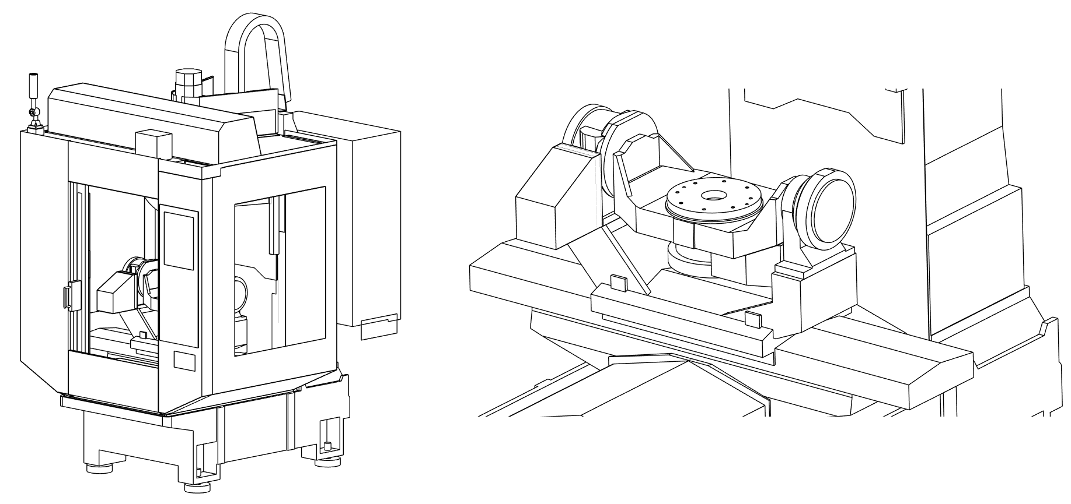

Rotary Table Setup Guide

Purpose: This document is intended to assist the user in adding a rotary table to an existing Machine Model suitable for simulation and collision checking in Fusion. This document is for milling machines – it does not address turning or additive machines.

This document is part of a collection named PPMS Partner Facilitation.
Copyright © 2025 Autodesk, Inc. All rights reserved

(Note that Table of Contents is made of hyperlinks. If viewing this document in Word, use ctrl+click to jump to pages in the Table of Contents, and use ctrl+home to return to top of document)

Table of Contents
1. Before getting started 3
A. First – make a copy of the machine model 3
B. Next – make a copy of the machine definition 4
2. Insert the rotary table model into the existing model 4
3. Machine Definition update 7
4. Use Machine Builder to link the new model to Fusion 10
5. Part location points for various conditions 12
A. ‘Part’ location when there is no rotary axis 12
B. ‘Part’ location when there is a rotary table 12
C. ‘Part’ location for non-TCP 4-axis table machines 13
D. ‘Part’ location for non-TCP 5-axis table-table machines 13
6. Export Machine Definitions – to transfer to other users 14
7. User Feedback 15
8. Useful Links 15

Note: It is strongly recommended that you review the other document in this series named ‘Creating Machine Models for Fusion’ before continuing with this document. This is because many of the processes covered in this document are examined more closely in the other.

Before getting started

Before making this kind of revision to a Machine Model it is strongly recommended you review the Workflow document titled ‘Creating Machine Models for Fusion’. The reason is because this document is structured for users who are somewhat familiar with the creation of these models that are part of Fusion’s simulation functionality.

Work with copies, not the originals!

First – make a copy of the machine model

Locate the Fusion model for the machine you will be adding the rotary table to and make a copy of it. The picture below shows the example created for making this documentation, and the steps are listed below.

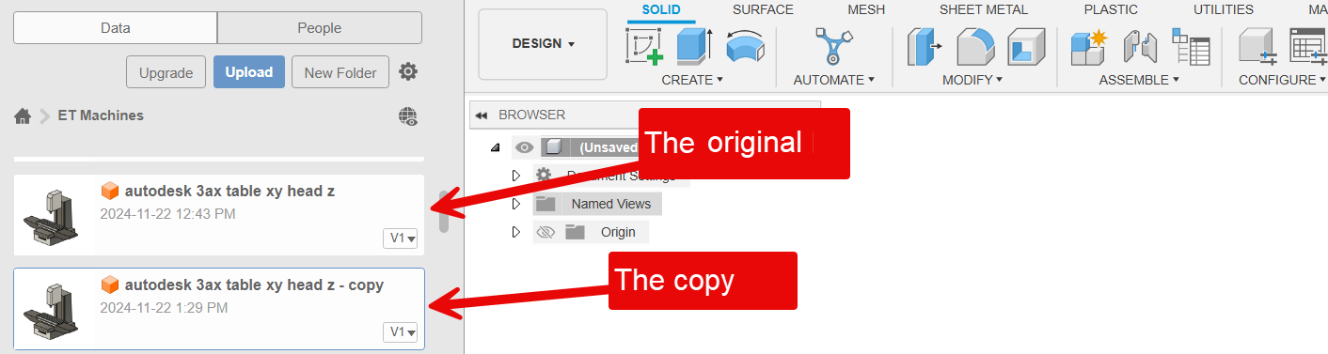

Make the copy by right clicking on the model in the data panel.

Choose ‘Copy’ and then pick the OK button.

Then right click on the copy and choose ‘Rename’

Supply the new name you want – remembering to be descriptive.

Next – make a copy of the machine definition

Make a copy of the Machine Definition that you will be using. The picture below shows the example used for this document. You can make a copy by following the steps below.

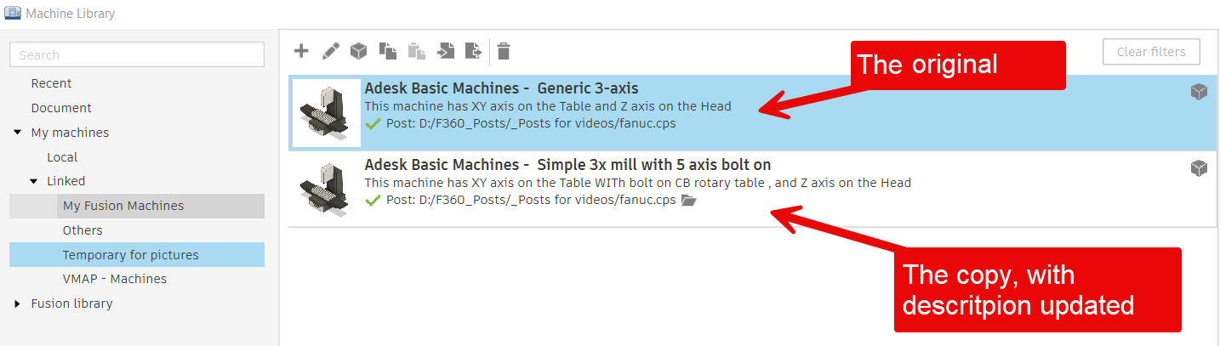

Open the Machine Library and select the Machine Definition you wish to add the rotary table to.

Use the ‘copy’ icon at the top of the dialog or right click on it and choose copy.

Paste it back into the collection using the ‘paste’ icon, or from the right click menu.

Use the ‘pencil’ icon to edit the newly created copy. Update the fields on the ‘General’ page. You want to have this information to clearly indicate this version includes the rotary table.

Insert the rotary table model into the existing model

You can find some rotary tables on the web in the same area as you find post processors and machines. If you have a machine model with the rotary table you want, you can copy it to a new file name and remove all but the rotary table.

This example covers adding a 5-axis rotary unit. Sometimes these are referred to as ‘bolt-on 5-axis units. Near the end of this document are tips on adding a 4-axis rotary unit.

Open the newly created copy of the machine model.

In the Design workspace, with the newly created copy of the machine model.

Find the model of the rotary table in the browser.

Because the rotary unit frame will need to move with the X axis table, you may want to save a bit of effort and have the X axis component active when you insert the rotary unit – as described in the next step.

Right click on the model of the rotary unit in the browser and choose ‘Insert into Current Design’ as shown below.

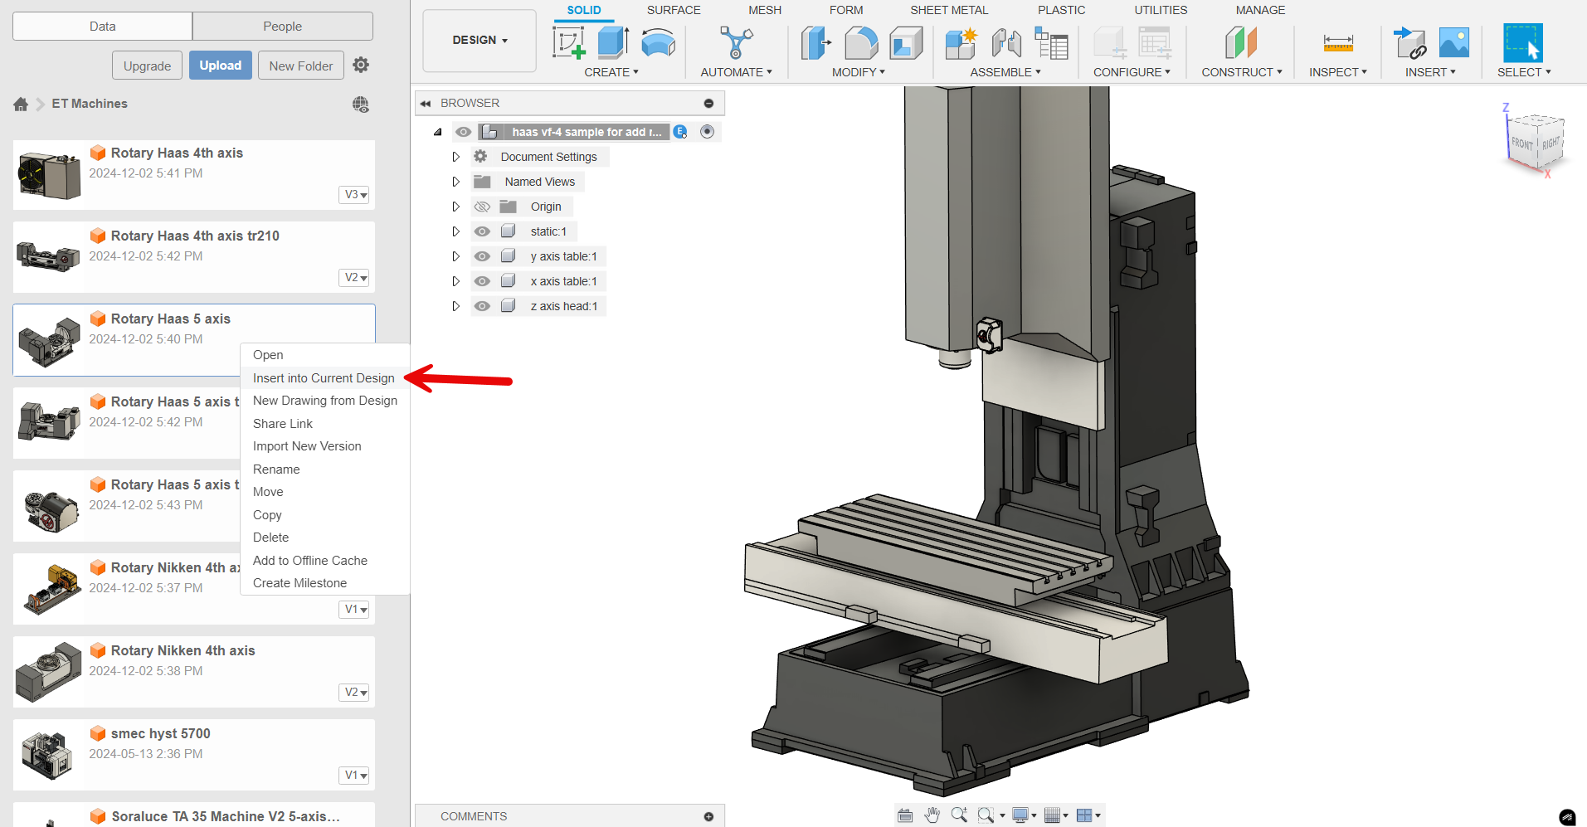

Position the rotary unit on the table. It is advisable to place it exactly where it will be located when it is actually bolted to the machine.

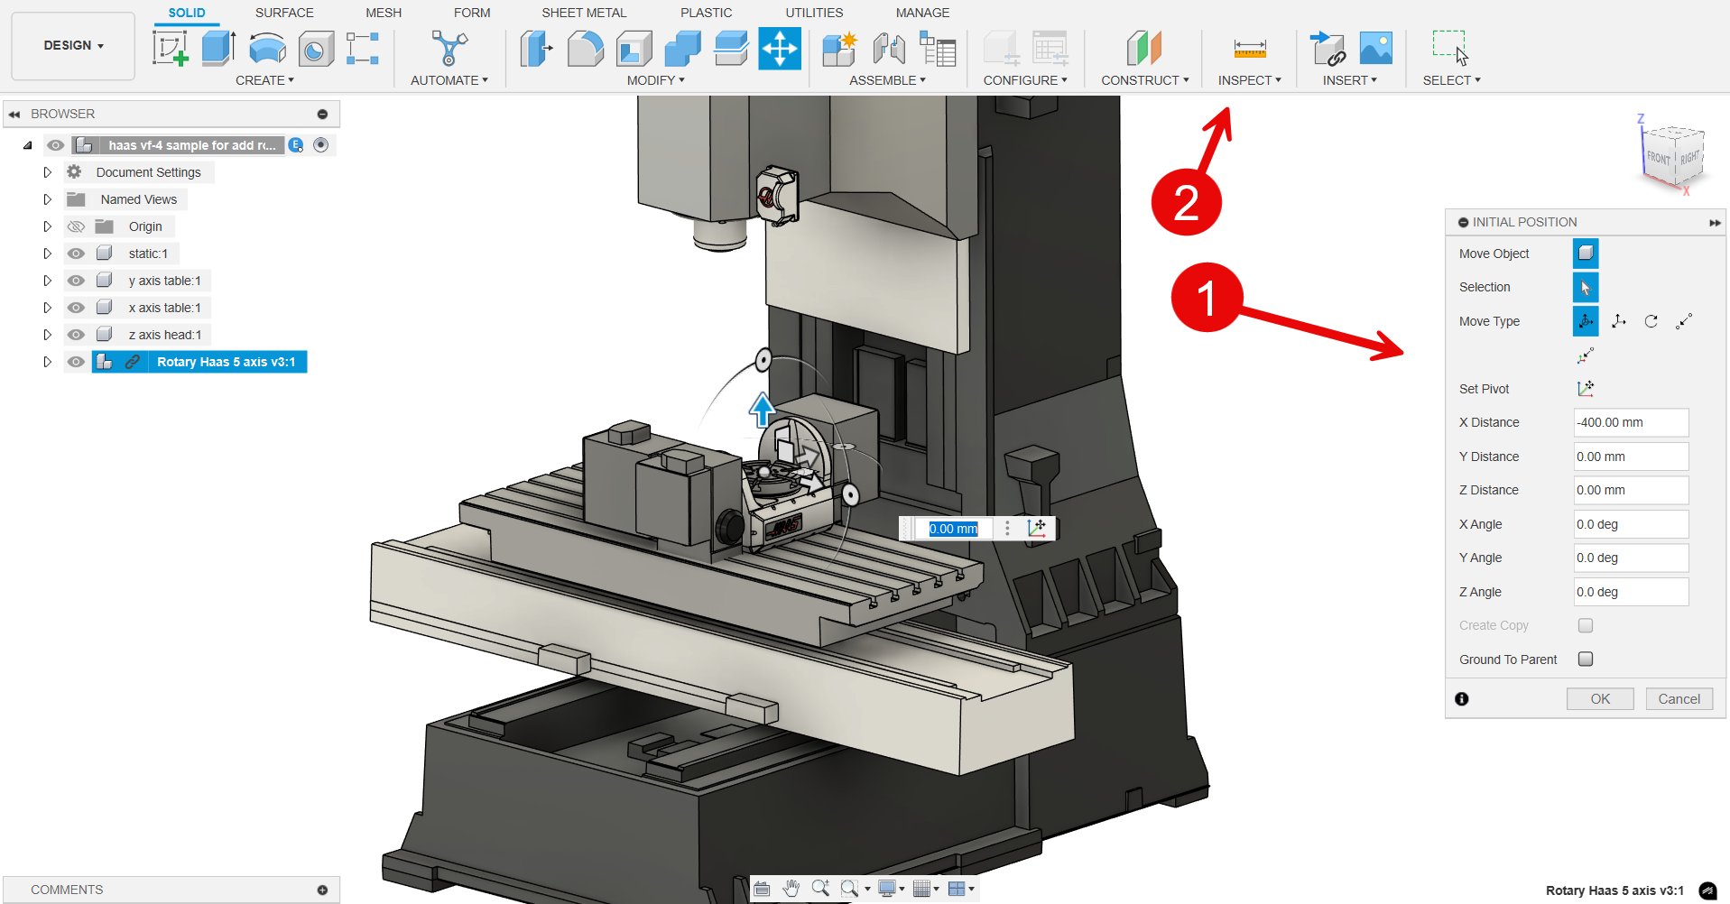

You can use the Initial Position dialog box (1), then the Inspection tool (2) to check that you have it located correctly. You will likely need to do a bit of measuring and positioning to get it exactly where you want it.

After positioning the unit, you will see the tiny icon of a chain on the left side of the component. The image below shows a paper clip icon (1) in front of the model’s name. Right click on the model and choose ‘Break link’ (2) to remove references to the original model.

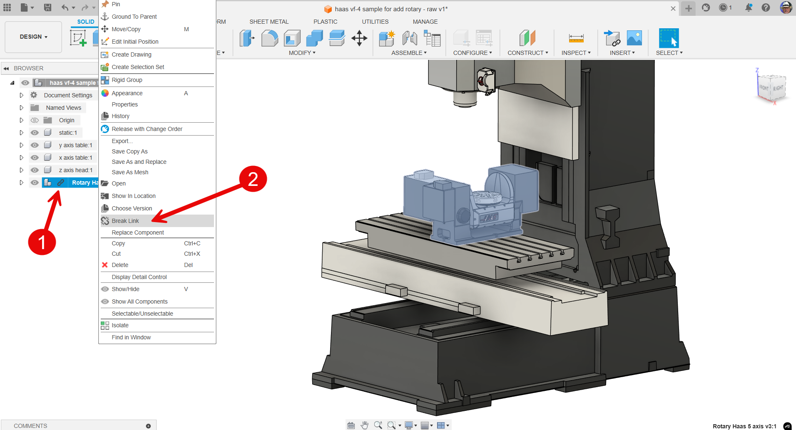

In the same way that you organize the machine parts when creating a machine model, you need to organize the parts after inserting the rotary axis. In this instance, the carriage or base of the rotary unit needed to be added under the ‘x axis table’ component as shown in the picture below. This is because they will move together.

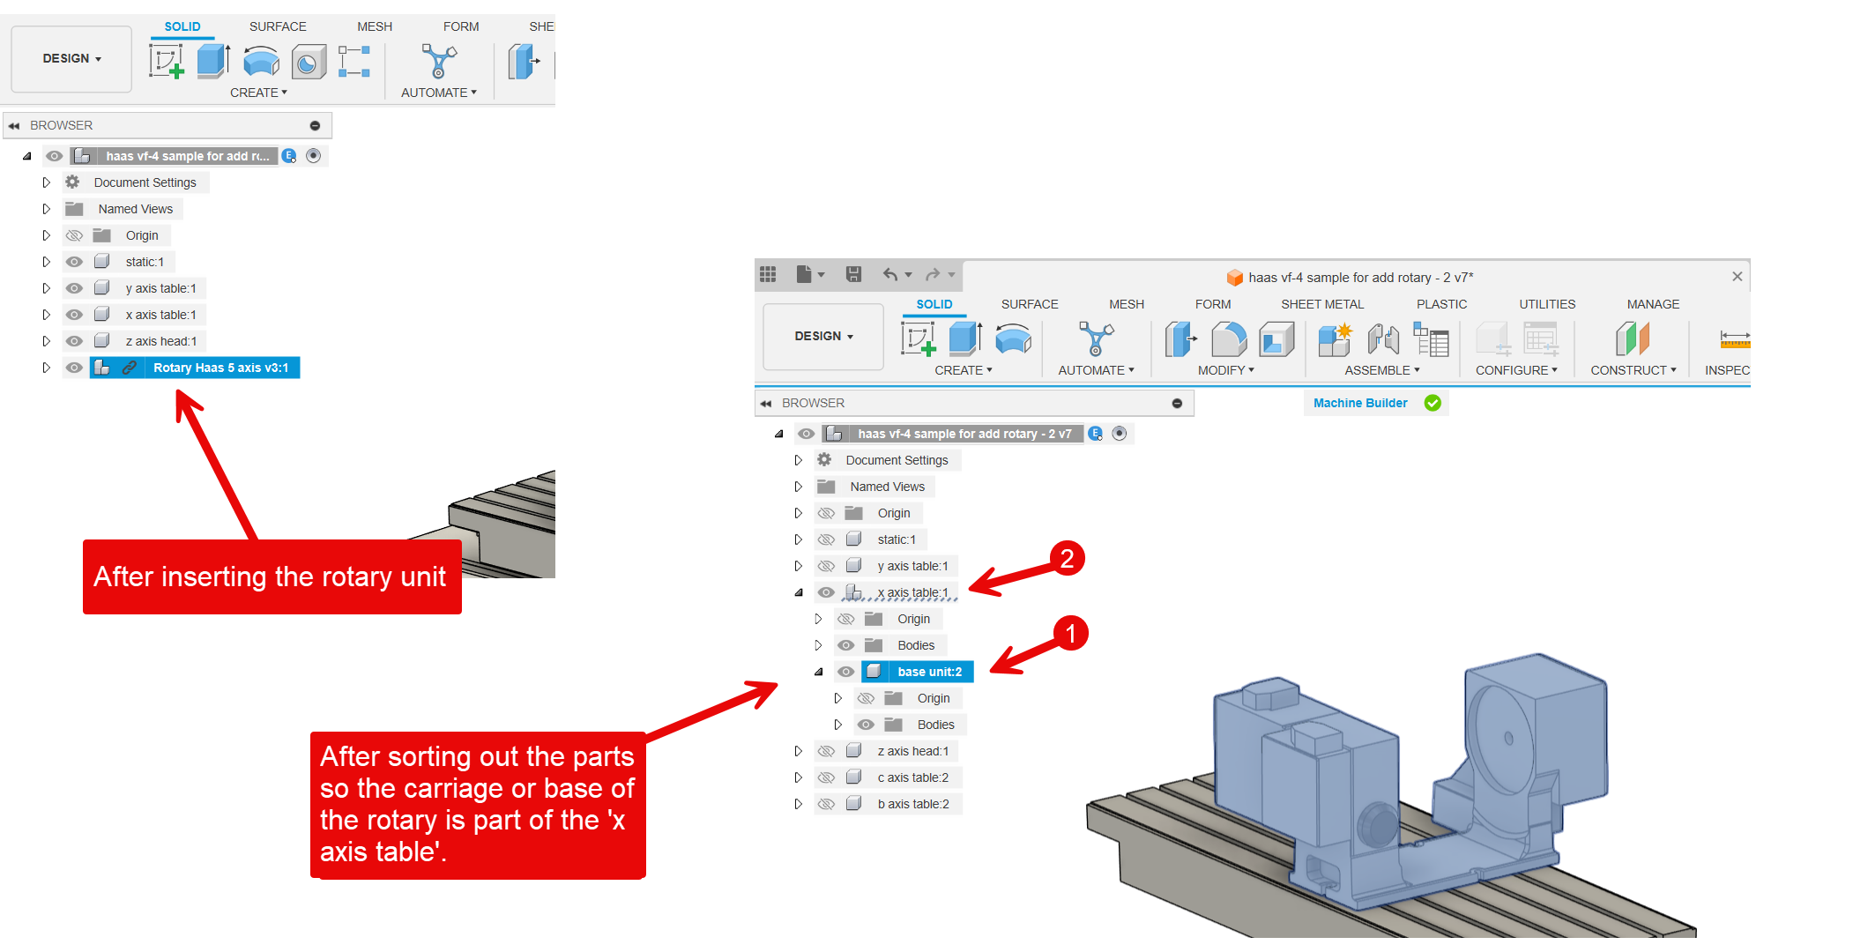

After you have broken the link, right click on the model again (1) and choose ‘Ground to parent’. This will prevent accidental moves.

Save this newly edited model of the machine.

Machine Definition update
After adding the rotary table to the machine model, the next step is to edit the copy of the Machine Definition that you made in step one of this guide. Begin by going to the Machine Library and selecting that Machine Definition you made by copying another.

Listed below is a guide to the steps needed to update the Machine Definition. The list is only a guide.

From the Manufacturing workspace, access the Machine Library.

Select the Machine Definition that you made by copying another.

Use the pencil icon to edit it.

Check that the information under the ‘General’ tab is as you want it.

Visit the Kinematics tab and add the rotary axis

Adjust all the settings as needed.

Note that The C axis normally rotates around the Z, but the A or B axis needs to be carefully set to rotate around the correct axis.

The picture below highlights a couple fields to check carefully.

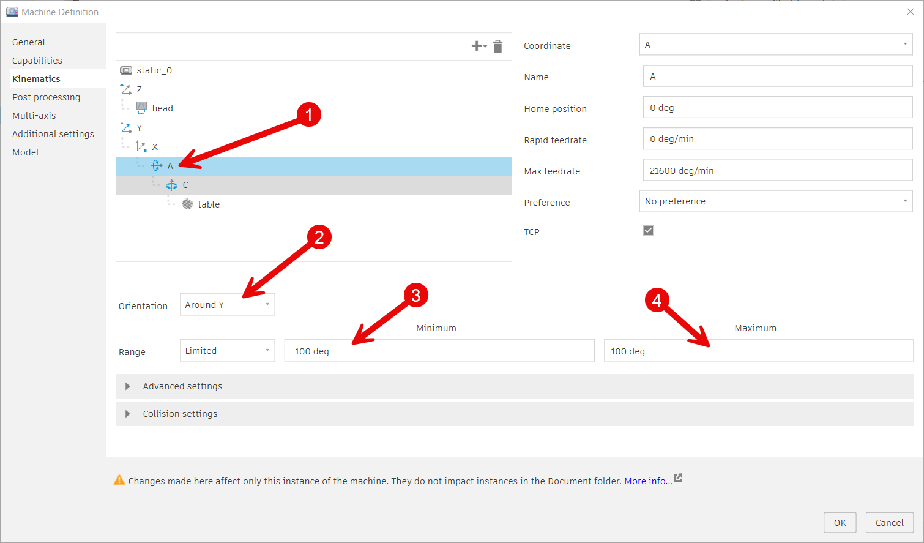

For multi-axis machines, the rotary axis information is crucial for sending data to the post processor to create NC programs. Here are some important settings to consider:
  - TCP: Controls whether the tool center point axis is supported.
  - Orientation: Determines the rotation of the selected rotary axis and the axis it rotates around.
  - Range: Specifies the supported range of the selected axis.
  - Preference: Specifies the preferred direction of tilt/rotation of the axis.

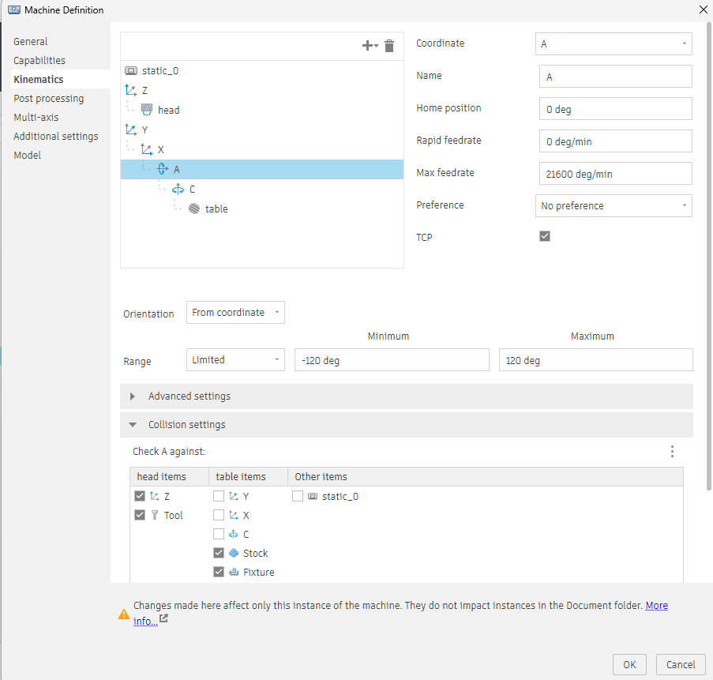

The collision setting allows you to control axis collision checking against other axes. Note that enabling the collision setting for multiple items could slow down the verification process during simulation.

Post Processing:
This tab allows you to set the default post processor and output folder for the machine. By doing this, when the machine is selected in the NC program, it automatically sets the corresponding post and output folder.
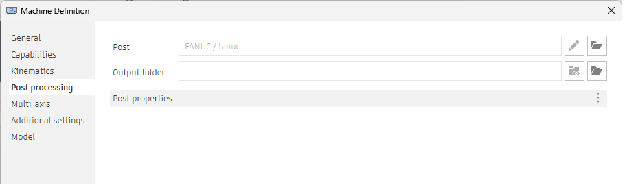

Mutiaxis setting:

- This setting allows you to control some of the multi-axis settings during post-processing:
  - Retract and Reconfigure: Enables the machine to rewind during simultaneous toolpaths. This occurs when the rotary axis reaches one of its limits, requiring you to reposition the tool. This mostly happens when both rotary axes are limited to a certain range.
  - Feedrate Method: Specifies the preferred feedrate method during post-processing of multi-axis toolpaths.
  - Adjust Singularities: Optimizes the simultaneous multi-axis toolpaths for singularities.

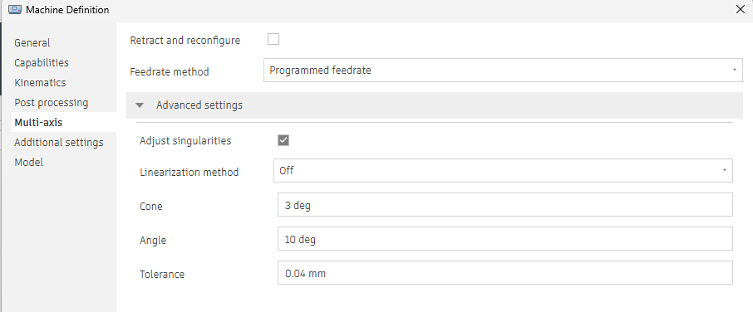

Define machine model:

Click on ‘Model’ (1) in the left menu.

Now because the old machine model (before the rotary table was added) is linked to this Machine Definition, use the X icon (2) in the upper right corner to delete the machine model.

Then use the folder icon (3) to select the machine model you added the rotary table to.

Click on the ‘Machine Builder…’ button (4) to enter the Machine Builder contextual environment (workspace).

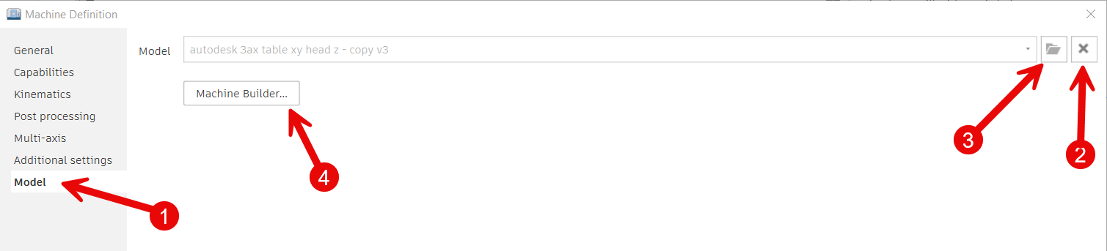

Use Machine Builder to link the new model to Fusion

The Machine Builder workspace shown in the picture below has the ‘Setup Machine Model’ button. It brings up a dialog box you use to effectively pair-up the model parts you have carefully named and organized, to Fusion’s record of what those parts are.

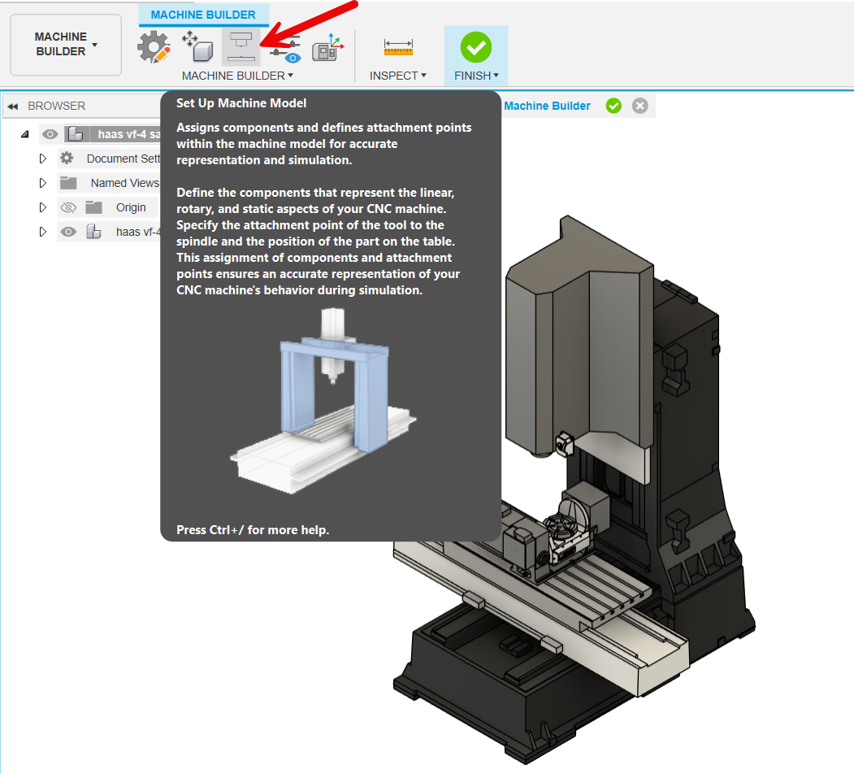

Because you are editing an already working Machine Builder model, you can click on the ‘Tool’ and ‘Z’ fields to see the selections that were made. The picture below shows some of the fields you will need to reset. You will need to reselect the ‘Part’ (1) to show the origin of the part is now the center of the rotary axis.

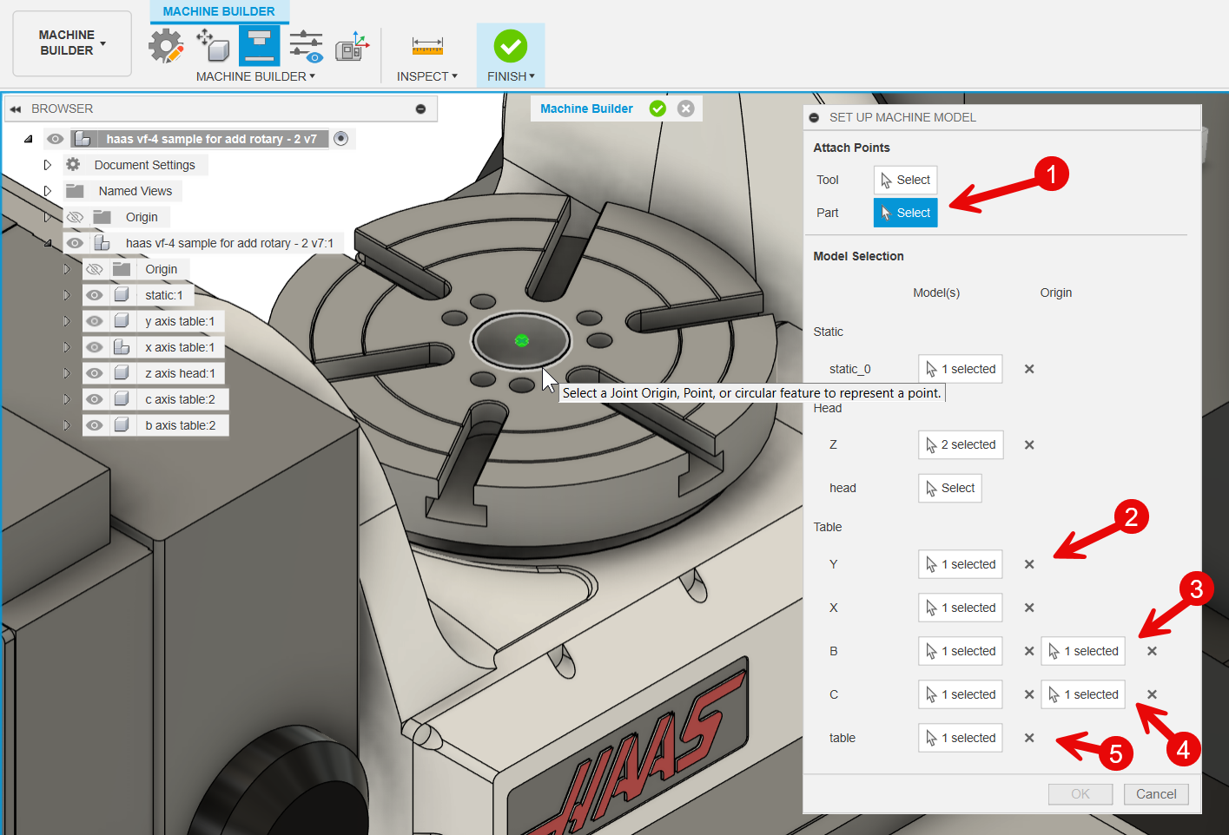

The tool tips should provide enough explanation to help you along in supplying the information for each of the other fields and the rotary fields. One thing to be careful of is to avoid accidently selecting surfaces while defining the Tool/Part attachment and the rotation points. They need to be points.

There are links at the end of this document to videos that walk step by step through the process of connecting the model components to Fusion.

After you have paired-up the components in the model to the fields in the ‘Setup Machine Model’ dialog box, use the icon for previewing machine movements (icon looks like 3 sliders) to test that you have the correct settings. It is strongly recommended that you test these motions before continuing.

When you are satisfied that you have the machine model parts connected to Fusion correctly and tested the motions using ‘Preview Machine Movement’, use the icon with large check mark on a green background to return to the Manufacturing workspace.

That completes the process of adding a rotary unit to a machine model.

You will probably want to open a manufacturing project and test your machine by adding it to a Setup.

If you the discover changes are needed, you can get back to the Machine Builder workspace by going to the Machine Library, selecting the machine from the list in the center of the dialog, then using the pencil icon (just right of the large plus icon) to reenter the Machine Definition where you can use the menu choice ‘Model’ again.

Part location points for various conditions

‘Part’ location when there is no rotary axis
The ‘Part’ position is normally the top center of the table for machines without rotary axis on the table. You can create a point at that location in the Design workspace using intersecting diagonal lines as shown below.

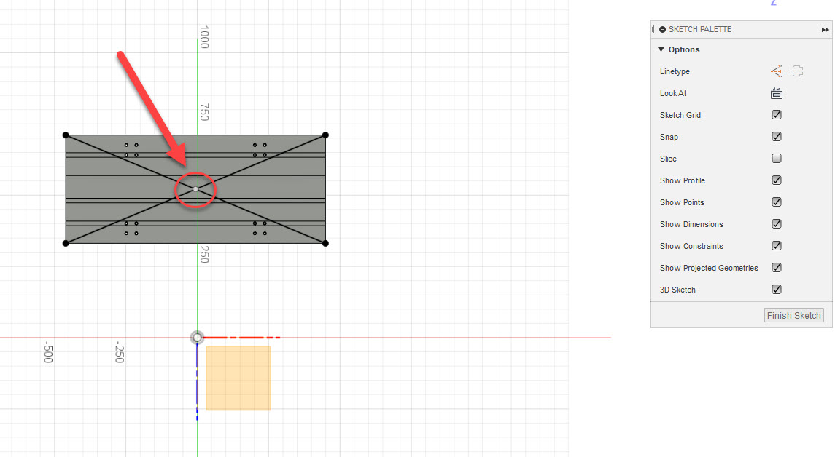

‘Part’ location when there is a rotary table

If there is a rotary axis on the table, the top center of that rotary table is where the ‘Part’ position should be set. The exception is non-TCP machines – as described in the section below.



‘Part’ location for non-TCP 4-axis table machines
The ‘Part’ position must be set to the center of the rotary face.

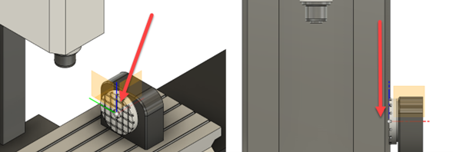

‘Part’ location for non-TCP 5-axis table-table machines
Machines without TCP require a bit more attention when setting the ‘Part’ position. The distances shown in the picture below should be measured so they can used to set fields in the kinematics section of the Machine Definition.

Normally (almost always) the ‘Part’ point will be set at the center of the rotary axis, but if it set at the back, the Y axis offset will be needed.

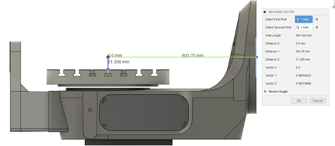

For non-TCP table-table machines as in the picture above, the following settings are needed.

The toggle for TCP should be set to OFF. (For all rotary axis without TCP)

Under ‘Advanced settings’ when the reset button is pressed automatically the offset distance will be captured from the machine model based on the specified table origin and the specified rotary axis point.
Note* Make sure to check the offset value as per the machine calibration report since this affects the NC program.

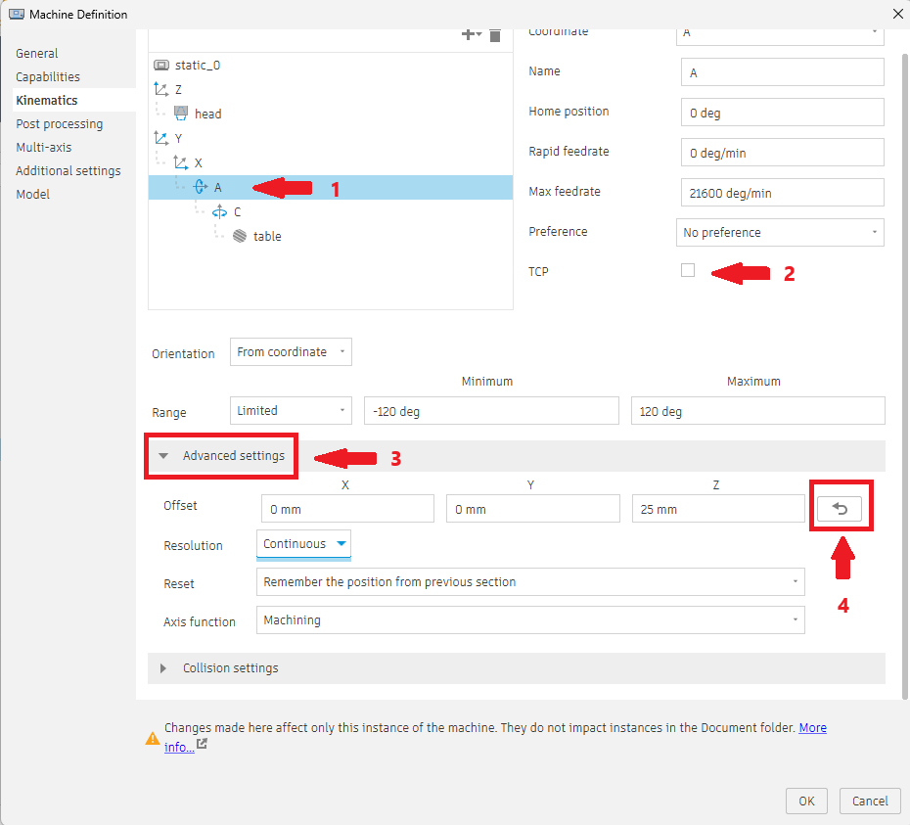

Export Machine Definitions – to transfer to other users

If you want to send a Machine Definition to another Fusion user, you can use the ‘Export Selected’ icon at the top of the Machine Library dialog, as shown in the picture below.

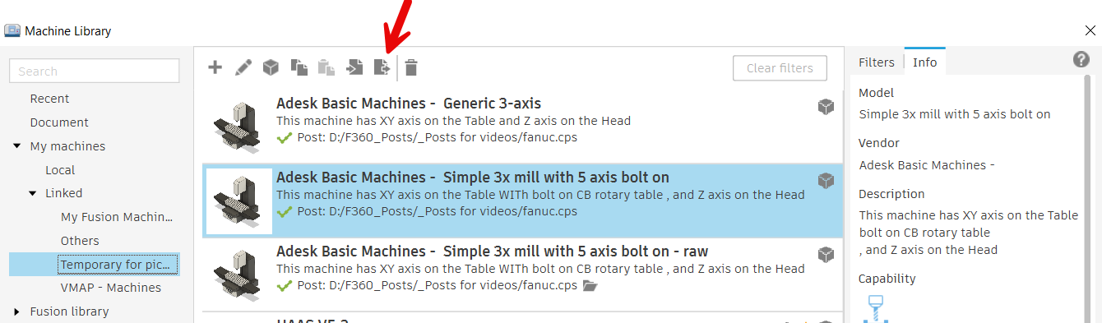
`
And the icon to left of it is for importing Machine Definitions.

User Feedback
If you would like to provide us with feedback on this document, or suggestions for other documents like this, please send email to:

channel.posts@autodesk.com

Please set the subject of the email to read: Feedback on Milling Adding Table

Useful Links
The links below provide additional information and instructions on related subjects.

- Fusion Help | Machines for manufacturing | Autodesk
- Machine Builder
- Workflow: Building a machine for machine simulation
- Fusion Help | Preview a machine’s movements in the Machine Builder | Autodesk

